1. In Git-Craken login into GitHub and File->Clone Repo
2. Where to clone to: c:\Models (you may have to create this folder first – see below)

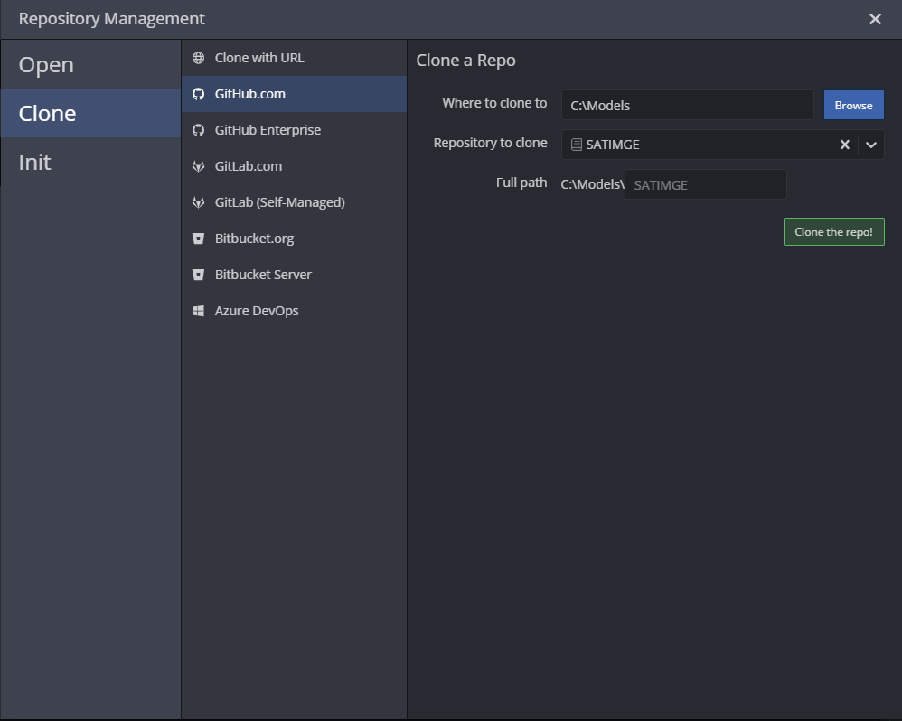

1. Put you ANSWER license .lic file in the SATIM folder.
2. Unzip rar file to get mdb
3. Test that RUNZERO runs on your computer, running in ANSWER.
4. To get results open GAMS and open the SATIMGE_04.gpr
5. Run SATIMGE.gms. The runs are controlled from SATIMGE.xlsm but not all features are working yet. I will send new version tomorrow.
6. This will put the results of your latest run into a file called REPORT_00.csv in the SATIMGE folder
7. Try open the Tableau file in the same folder (not the one that was emailed)
8. To make changes:
   1. Start a new branch named after your sector
   2. Make changes in spreadsheet/model
   3. Import from excel with updates, ANSWER will automatically ask you to confirm the export to .imp file which you should accept.
   4. You can check that change appears in GitCracken
   5. When you are done you can stage, commit and push to server
   6. I will manage the merging of branches for now

Have fun!